Transactions
Transactions allow us to test the result of a query without affecting tables in a database.
We can execute some query and then revert all the changes made by this query. For example we can modify an existing table and then revert those changes.
We can do it like that:
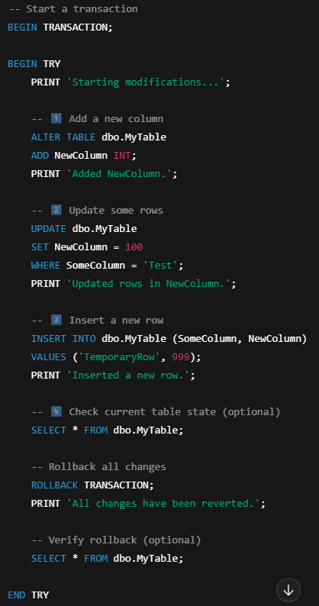
The ‘ROLLBACK’ command reverts all the changes we made.

Temporary tables
Temporary tables allow us to create tables which are variables. They exist only in a session, in a script, but they are not saved permanently in database.
This is useful if we want to create some table just for a moment, for the time of working with a single script and then delete it.

